Runcorn Pride in Place
Small Grants Programme 2026 / 27 – Round Two

Grant Information

What is Pride in Place?

Pride in Place is a 10-year government programme giving communities the power and funding to improve local spaces, support culture, and boost pride in where they live. Runcorn is one of 250 areas that will have £20 million investment over 10 years. Through community consultation, local people have already identified key themes that they would like to see implemented in Runcorn Old Town

Why a Small Grants Programme?

When residents want to make a lasting difference in their local area, they often need modest funding to get started. Community grants—sometimes known as community pots or chests—offer small but strategic amounts of money to help turn local ideas into action. A targeted small grants scheme will enable local action, encourage participation, and unlock the potential of grassroots groups who are often best placed to understand and respond to local needs.

What are the aims of the Grants Fund?

The key aims of the project are to:
- empower local people to take action in their community
- promote inclusion, wellbeing, culture and local pride
- increase community participation and volunteering
- strengthen local networks
- improve visibility and vitality of Runcorn and the Old Town

How much can I apply for?

There are two sizes of grant pots available:

- Micro grants of up to £250 per project

Specifically aimed at young people aged 14 – 25 years who want to make a difference. They are open to individuals or a group of individuals who may be part of a charity or organisation (unconstituted group). Applicants will need to show they are or will, work in partnership or with residents to apply.

- Grow grants of £1k - £5k per project

These are open to registered charities, CICs and voluntary / community organisations. Priority will be given to smaller grassroots organisations.

Funds can be used to:
- kick-start grassroots projects
- support new or emerging community groups
- enable community led activities that promote Pride in Place, wellbeing and social inclusion
There are two rounds of applications for 2026/27 to allow groups the opportunity to develop ideas. Organisations or individuals can only apply once across the two rounds.

Round 1 – Applications opened January to mid-March 2026 with decisions and grant payments made in May 2026.
Round 2 – Applications open 17th July to 11th September 2026 with decisions and grant payments in October 2026.

What can be funded?

Eligible projects may include both revenue and capital funds for example:
- Community events and celebrations
- Environmental improvements or planting schemes
- Youth activities or intergenerational projects
- Arts, heritage or cultural projects
- Equipment for local groups
- Activities to address loneliness, health and wellbeing
- Projects that help people feel safe and improve community cohesion

What we cannot fund

Generally funding is NOT available for the following purposes:
- Core Funding
- Projects that do not benefit Runcorn Old Town and the surrounding areas (please see map in guidance)
- Personal expenses that are not project related (if unsure, please ask for guidance)
- Retrospective costs (events or equipment you’ve already purchased)
- Political / religious activities

Further Help and Support

If you have any further questions regarding the grants or need any help completing your application form, please contact Jo Beech (jbeech@haltonsthelensvca.org.uk)

2026 Second Round Timetable:
- Applications open for submission from Friday 17th July 2026
- Closing date for applications Friday 11th September 2026
- Grant panel meet on Monday 28th September 2026
- Decisions communicated to applicants within 1 week

Runcorn Pride in Place
Small Grants Programme 2026 / 27 – Round Two
Grow Grant Application Form

Name of Organisation:

Address:

Contact names and details:
 | Main Contact | Second Contact
Name:
Position:
Telephone:
Mobile:
Email:

What type of organisation  are you? | ☐ Registered Charity ☐ Social Enterprise  ☐ Club ☐ Society  ☐ Community Interest Company  ☐ Not-for-Profit Community Business  ☐ Unregistered Community Group
Other, please state:
What is your registered number (if you have one)
What are the aims of your organisation? (Just a summary, 50 word max please)

- What do you want to do? 20%
- How does this meet the themes of the programme?
(the themes under which Pride in Place is being built on) 20%
 | - What do you hope to achieve – what are the intended outcomes? 20%
 | - How are you going to promote what you do? 20%
 | - What will it cost? Please provide a breakdown 20%
 |  | £
 |  | £
 |  | £
 |  | £
 |  | £
 |  | £
 | Total Grant Requested | £

Declaration

Before signing the declaration, please ensure you have completed all the questions in this application form,

Please confirm you will attach a copy of your organisation’s most recent bank statement

Please confirm by ticking the checkboxes that the following documents are available upon request:

Constitution / set of rules of your organisation

Latest annual accounts, or income/expenditure
statement for the last 12 months

A copy of your organisation’s Safeguarding Policies

I am an authorised representative of the organisation. To my best knowledge,
the information provided in this application form is correct.

Signature:
Print Name:
Position in Organisation:
Date:

Please return this form by 11th September 2026 as a WORD document to: grants@haltonsthelensvca.org.uk or complete this form online.

Runcorn Pride in Place
Small Grants Programme 2026 / 27 – Round Two
Micro Grant Application Form (Age 14-25)

Your Name and Organisation Name (if applicable or the group that you are linked with):

Date of Birth:

(You must have been born between 1st April 2001 and 31st March 2013 to apply for the Micro Grant fund – Age 14-25)

Phone Number:

Email Address:

Tell us about your idea

- What would you like to do with the grant?
(What activity, event, project or improvement would you like to make happen)
What would you like to do with the grant

- Who do you think would benefit from your project? Who is it for? For example:-

- Young people
- Families
- Older residents
- The wider community

How many people do you think could get involved?

Who you do you think would benefit from your project

- Why is this important?
(What difference will your project make to Runcorn Old Town or the people who live there)

- What would success look like to you for this project
(How will you know your project has gone well?) For example:-

- Lots of people took part
- The area looks better
- People learned something new
- People made new friends
- People felt happier or safer

Please return this form by 11th September 2026 as a WORD document to: grants@haltonsthelensvca.org.uk or complete this form online.

Guidance Notes
About Your Organisation

Please complete in full and ensure that you give a second contact for your project.

About your Pride in Place application

- What do you want to do? Please describe your project.

In this section we want you to tell us the who what, when and where of your project where applicable:-

- Who – will you be working with etc. and how will they be encouraged to take part?
- What – activities / interventions are going to take place?
- When – will they take place e.g. weekly / at weekends / evenings etc
- Where – please tell us where the grant will have an impact or be located – applicants can live / work / be based outside of Runcorn Old Town, but activities MUST take place within Runcorn Old Town – see map below

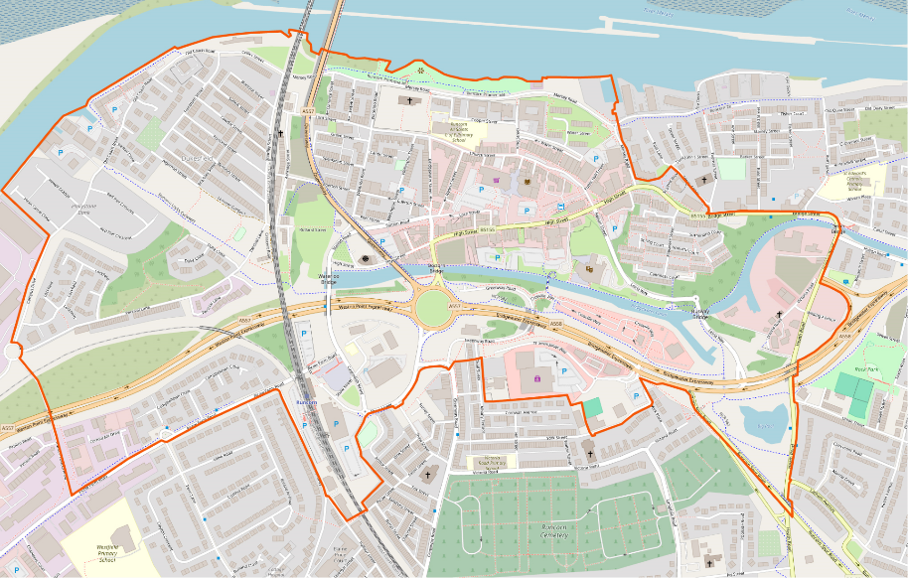

- How does the project meet the themes (see following list)
- In this section tell us how you know that the intervention / activity / project you are planning links to one or more of the key themes identified.

- What do you hope to achieve / what are the intended outcomes
- What does good look like? How will you know you’ve been successful?

4. How are you going to promote what you do?
- Tell us how you plan to get people involved if applicable.

Financial Information
Please give a clear breakdown of project costs including any management costs and any additional funds that you may be seeking from other sources to support the project.

Runcorn Pride in Place

Key Themes
Regeneration, High Streets and Heritage

- Improvements to town centres, neighbourhoods, and high streets, including capital spend and running costs
- Creating and improving green spaces, community gardens, watercourses and embankments in the local area, along with incorporating natural features into wider public spaces
- Support for non-domestic energy efficiency measures and decarbonisation in local businesses, high streets, and community infrastructure
- New community and neighbourhood infrastructure projects, or for improvements to existing ones.
- Enhanced support for arts, cultural, heritage and creative activities, projects and facilities and historic institutions that make up the local cultural heritage offer
- Local arts, cultural, heritage and creative initiatives
- Investment and support for digital infrastructure for local community facilities
Work, Productivity and Skills

- Support to improve awareness of, and access to, local provision that moves people closer to and into sustained employment, in line with an area’s Get Britain Working Plan
- Funding to support the development, improvement, and promotion of the visitor economy, such as local attractions, historical trails, cultural tours, campaigns and other related tourism products
Cohesion

• Measures to improve community cohesion

Community Power

- Delivering engagement, participation and involvement activity to give communities a role in decision-making
- Giving communities a role in the design and delivery of local services
- Enabling community wealth building

- Support for growing the local social economy, including community businesses, co-operatives and social enterprises
- Funding for impactful volunteering and social action projects to develop social and human capital in local place
- Investment in capacity building and infrastructure support for local civil society, youth and community groups

Health and Wellbeing

- Supporting community-level health provision
- Integration and co-location of health and wellbeing services
- Funding for local sport and activity facilities, events, teams and leagues, to foster community engagement and connection
- Funding to support preventative public health initiatives and campaigns
- Provide drug and alcohol support for people with experience of homelessness and rough sleeping

Transport

- Support for active travel enhancements in the local area

Safety and Security

- Design and oversight of the built and landscaped environment to ‘design out’ crime and encourage positive behaviour
- Interventions to tackle anti-social behaviour, crime and minimise reoffending

Education and Opportunity

- School-based programmes to support young people’s development
- Support to both reduce levels of child poverty and to prevent the negative impacts of child poverty on children and families
- Support for families and young children
- Funding to help families with the cost of childcare where it may alleviate cost of living pressures, or support employment
- Support for community-based learning and development

Thank you for interest, we look forward to receiving your application.

