‘Building Bonds & Breaking Cycles’
1 Day Parent Infant Mental Health Training

Giving Families the Best Start in St Helens

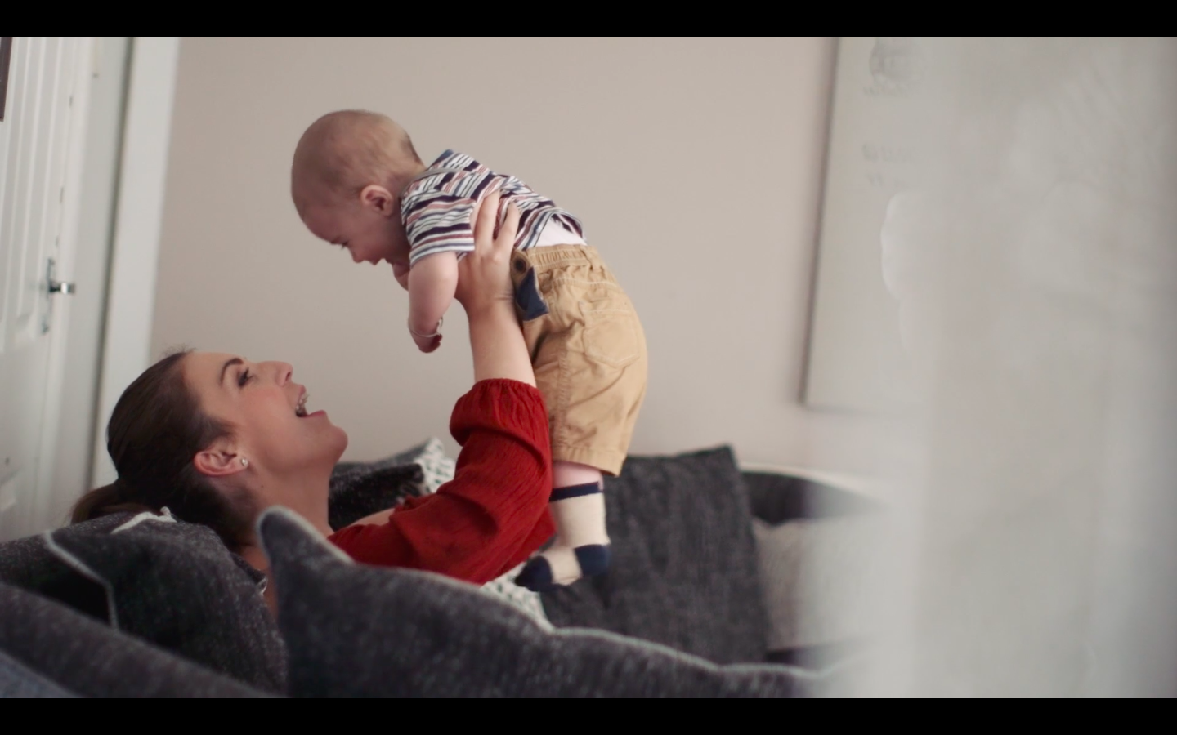
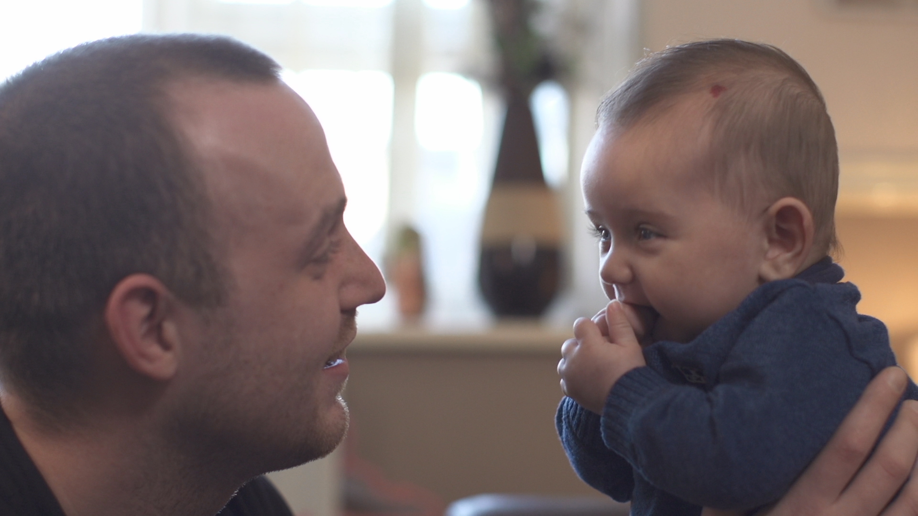

Building Bonds is offering 2 Day Specialist, therapeutic PIMH training courses to St Helens MDT Professionals working with parents & infants across the different systems: Maternity, Child Health, Mental Health, Children Centres/Family Hubs, Early Help, Childrens Social Care, Housing, Grass Roots Community/3rd Sector Services (Drugs & Alcohol, Domestic Violence, family support services).
This 2-day PIMH training course will equip Managers & Service Leads with greater ‘head space’, insight & understanding in how they can steer & support their staff/teams in developing their knowledge, skills, practice/care in the key PIMH areas of: Attachment, Separation & Loss, attachment-based interventions, Parent-Infant Mental Health, ACES, trauma & offering a more engaging, compassionate & ‘trauma informed model of care’.

The training will support Managers & Leads to reflect on how as multi-agency systems & professionals – we need to work collaboratively & be effective in both safeguarding children, alongside supporting vulnerable families to build good bonds/relationships, break transgenerational cycles & breakthrough difficult times, which will reduce risk/harm to infants.

We would like ALL St Helens Borough Service Leads & Managers working across the different Systems supporting parents & infants in the community to attend 1 of the following 1 Day Training Courses.

Course 1: Thursday 6th of July 2023 – 9.30pm-5.00pm, World of Glass, Chalon Way E, St Helens, WA10 1BX

Course 2: Thursday 28th of September 2023 – 9.30am-5.00pm, St Helens Chamber, Salisbury Street, Off Chalon Way, St Helens WA10 1FY.

Please contact earlyhelpadmin@sthelens.gov.uk to reserve your training place. Courses will fill up quickly so book your place asap! Training Venues will be confirmed before the 15th of April 2023.

I look forward to meeting you all soon.
Lisa (Dr Lisa Marsland, Consultant Clinical Psychologist)

