‘Building Bonds & Breaking Cycles’
2 Day Parent Infant Mental Health Training

Giving Families the Best Start in St Helens

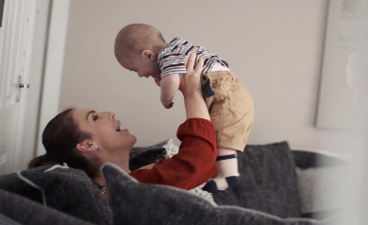
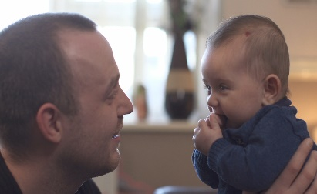

Building Bonds is offering 2 Day Specialist, therapeutic PIMH training to St Helens MDT Professionals working with parents & infants across the different systems: Maternity, Child Health, Mental Health, Children Centres/Family Hubs, Early Help, Childrens Social Care, Housing, Grass Roots Community/3rd Sector Services (Drugs & Alcohol, Domestic Violence, family support services).
The 2-day training course will equip MDT colleagues with greater understanding, specialist knowledge, tools, ‘head space’ & confidence in how to engage & work in partnership to support parents & infants in the key areas of: Attachment, Separation & Loss, attachment-based interventions, Parent-Infant Mental Health, ACES, trauma, offering a ‘trauma informed model of care’.

The training will put a spotlight on how we as MDT professionals can both safeguarding infants, alongside supporting vulnerable families to build good bonds, break transgenerational cycles & have the capacity to separate out their own issues/difficulties (ghosts from the nursery) from their children, & with MDT support …can breakthrough very difficult times.
ALL St Helens MDT professionals working across the different systems will be invited to attend 1 of the following training courses (April – October 2023)

Course1 – Monday 24th & Tuesday 25th April 23 – 10.00am – 4.00pm, World of Glass, Chalon Way E, St Helens, WA10 1BX
Course2 – Monday 22nd & Tuesday 23rd May 23 – 10.00am- 4.00pm, World of Glass, Chalon Way E, St Helens, WA10 1BX
Course3 – Thursday 22nd & Friday 23rd June 23 – 10.00am-4.00pm, World of Glass, Chalon Way E, St Helens, WA10 1BX
Course4 – Thursday 12th & Friday 13th October 23 – 10.00am – 4.00pm, St Helens Chamber, Salisbury Street, Off Chalon Way, St Helens WA10 1FY.
If you are interested in attending – Please email earlyhelpadmin@sthelens.gov.uk & reserve your place. Courses will fill up quickly so book asap! Training venues will be confirmed early April 2023.

